Drama on the Congo
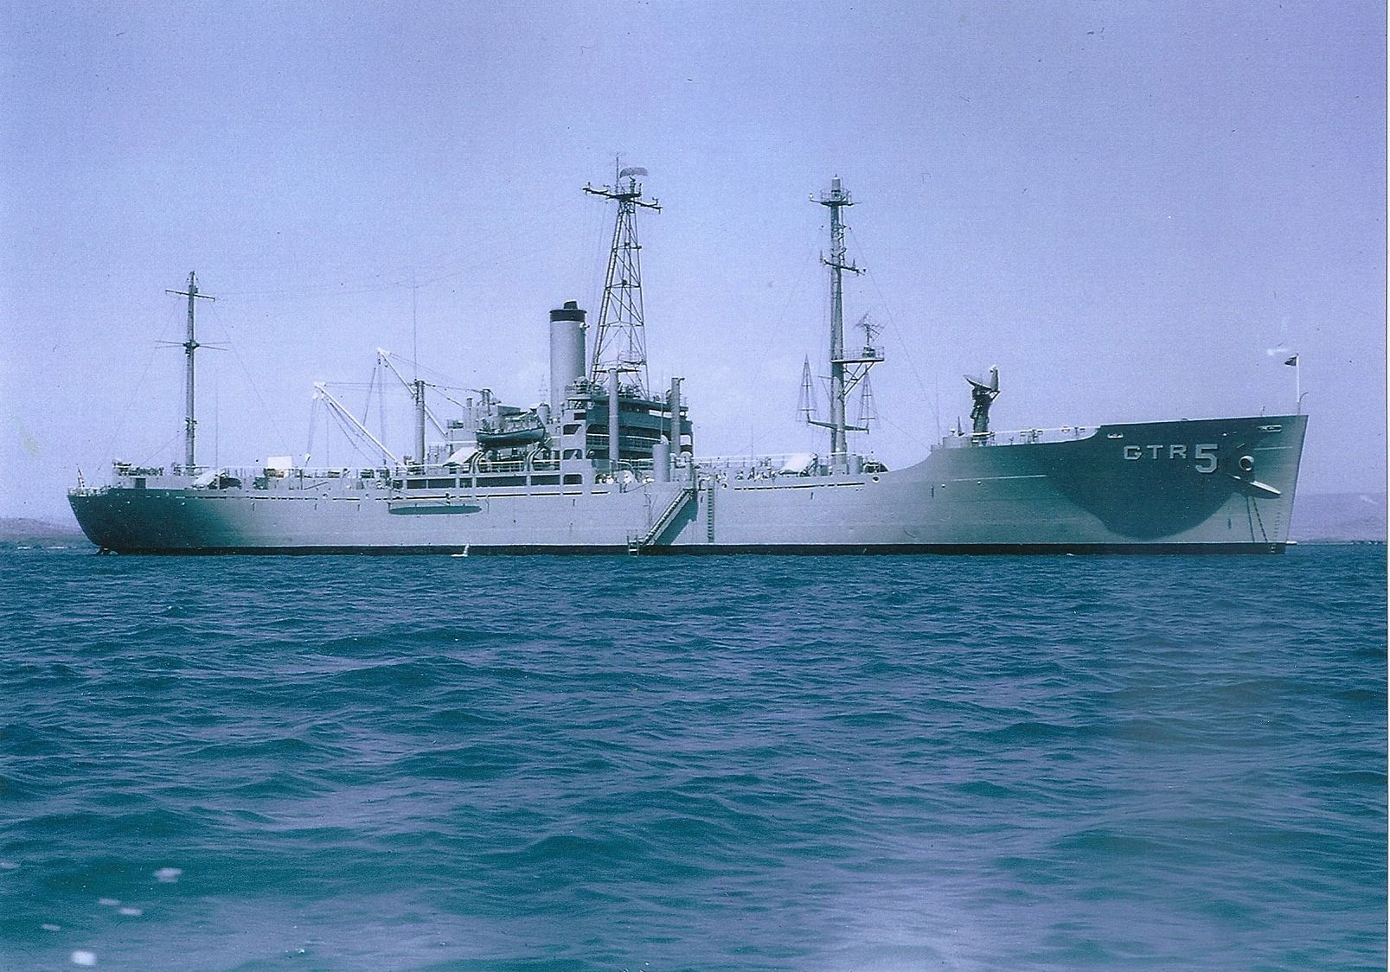

The USS LIBERTY, (AGTR-5), was cruising along, in calm seas, off the West coast of Africa in close proximity to the Congo River. Debris, consisting of fallen trees, planks of various sizes and an assortment of additional garbage constantly exited the Congo forming a trail into the Atlantic Ocean. The trail was visible for miles and those of us aboard LIBERTY waited to see if any bodies surfaced...the two Congo's, Brazzaville and Leopoldville were constantly at odds, and loss of life in these two countries was an everyday occurrence.
Communication Technician Seaman (CTSN) Bobby Ringe began his day in a usual fashion. After having breakfast, he went topside to catch a breath of fresh air while waiting for morning muster. He was scheduled to stand an evening watch, so, after muster, he had nothing to do. He left the main deck after muster and went to the radio space (RR1) two levels below the main deck because he had to see Joe Bonsignore. Bonsignore was standing the day watch and would be relieved in the afternoon by Bobby Ringe. Ringe opened the door leading to RR1 and walked over to the position occupied by Bonsignore and without thinking, picked up a set of headphones and put them onto his head. He realized he did this without thinking and immediately took them from his head and put them onto the position between the two receivers and the tape recorder.
"What are you doing here, Bobby," Bonsignore asked?
"I have a message for you," he chided. "Tommy Bird told me at breakfast this morning that it won't be long and you'll be able to play pinochle like the big boys!"
Just as Ringe uttered the last word, a strange pain invaded his right side His left hand went to the area and he pushed slightly against his side to help relieve the discomfort. It passed.
Bonsignore, chuckling, said, "You tell Mr. Bird that he's right. It won't be long and I'll get back some of the bucks I've donated to the Stenzel and Bird drinking fund!"
Ringe started to say something when a second and more predominant pain caused him to stop mid sentence to take a deep breath.
Bonsignore asked, "Are you okay, man?"
"I hope so," Ringe said. "I had this pain in my right side but it's gone."
"Better be careful," Bonsignore said. "It could be your appendix."
Ringe decided to go back to the berthing compartment in the after part of the ship. He left RR1 and stuck his head into the Coordination Center that was directly across the hall from RR1. He said hello to one of the Portuguese linguists that were sent from NSA for this TAD (Temporary Additional Duty) to Africa. He had met Dino when the group of eight had boarded the day before LIBERTY left from Norfolk. He needed a new pinochle partner and Dino might be the right person.
He let the door close and headed for the ladder that would take him to the next level up but still one level below the main deck. As his foot hit the second step on the ladder, a third and decisive pain persuaded him that perhaps Bonsignore was right. It could be his appendix so a trip to sick bay was in order.
Ringe's trip to sick bay took a long time. He made stops along the way clutching his side as pain after pain wracked his body. He made it up the ladder to just outside the door leading to sick bay. As he opened the door, an excruciating pain made him so ill, he barfed up some greenish fluid. The corpsman standing inside the door took notice because most of the greenish fluid landed on his shoes. He grabbed Ringe as he started to fall to the deck and placed him on a patient table on his back. He yelled to the doctor who was in the next room redressing a wound one of the deck personnel had gotten a few days earlier.
"Doc," he said. "Ringe has bad pains in his right side and he just threw up some green stuff. The doctor did some preliminary doctor shit and determined that it was, more than likely, an appendix problem. The doctor decided that Ringe needed surgery, as soon as possible.
The doctor and the corpsman both knew that there wasn't enough general anesthesia to complete an operation. They had used most of what they had the previous week and wouldn't get more until they pulled into their next port for liberty. He did have sufficient ether to perform what is called an "open drop" but he had never done that before and was afraid to risk it on Ringe. There wasn't much time and the life of this young man was in his hands.
The Commanding Officer, Commander Daniel Wieland, had been notified of what was happening. He raced to sick bay and the doctor and the CO put their heads together. Ringe needed surgery, so he had to be transported someplace where the surgery could be performed.
The skipper and doc went to the ship's general service radio shack on the main deck. An urgent radio message was sent to the Commander in Chief of the Atlantic Fleet (CINCLANTFLT) for an appropriate answer. CINCLANTFLT contacted the American Embassy in Brazzaville and arrangements were being made to transport Ringe from LIBERTY to the Naval Hospital in Tripoli. There was a slight logistics problem that had to be resolved. How do you get a man from a ship at the mouth of the Congo River to Tripoli for surgery to perhaps save his life???

The USS LIBERTY was on station adjacent to the Congo River off the East coast of Africa.
A sailor, Bobby Ringe, became ill and the doctor and his staff decided the affliction was probably an appendicitis attack.
They tried a simple ether drop that didn't work.
Bobby needed to get to a facility that could perform surgery.
The USS Liberty was in proximity of the Congo River.
There were two facilities, the Congo Leopoldville and the Congo, Brazzaville.
Leopoldville was supporting communism...Brazzaville was trying desperately to maintain a democratic and free society.
The United States analyzed her position and decided that if we could safely get the subject sailor up the river (the Congo), we could successfully move the sailor to a facility that could treat his apparent appendicitis.
The word was "go," and Liberty began a trek up the Congo to a port named Banana, approximately 12 miles.
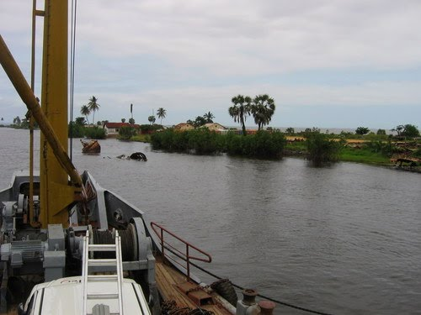 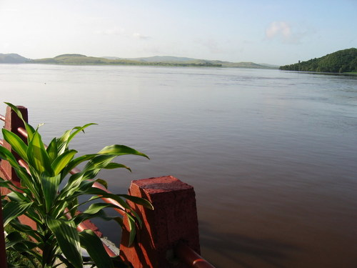
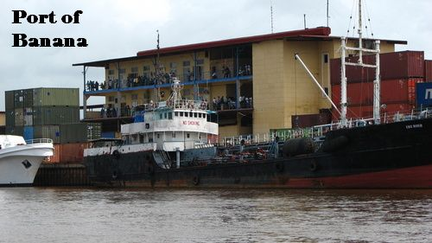
We dropped anchor, and made preparations to get Bobby off Liberty.
The facility at Brazzaville had a boat approach the ship.
Bobby was moved to the boat and was now on his way to the airport where a United States Navy plane was waiting to transport him to a hospital in Libya.
We had guests from Leopoldville board the ship. The guests gave us explicit instructions.
Be prepared for a team of people to board your ship tomorrow morning.
"You will not leave until we conduct our inspection."
You're on a United States Navy ship sitting in the Congo River and that ship just released a sailor who needed medical assistance to an entourage of people who we assumed were friendly. We pray that he makes it to Libya.
We operated independent of the fleet but were still under the jurisdiction of the fleet. However, we were also working for the National Security Agency (NSA).
To the best of my knowledge, the Commander in Chief of the fleet said to stay anchored and get inspected. NSA said, “Get Your Ass Out Of There!”
The Commanding Officer, CDR Dan Wieland, and the ship’s officers met and came up with a scheme. They first wanted assurance that Ringe was safe.
Liberty was anchored with her bow facing up the fast streaming Congo River. The current was very swift and powerful. It was decided that if the anchor were lifted, the bow of the ship would swing in the direction of the Atlantic Ocean. The bow would then be positioned correctly for movement down the river to the Atlantic.
I think 2300 hours was when the event was to take place. Once the ship had swung around, the engines would be started and full throttle would be engaged. An order to darken ship was given prior to the raising of the anchor.
At 2300 hours, with Ringe safely on his way, the anchor was raised, the ship began to turn and the engines were started. The entire ship was vibrating so much, it was thought she would fall apart. The ship inched forward and we could hear what sounded like wood crunching and metal being ripped apart. We theorize that a blockade was created aft of Liberty to block any attempts to escape. The crunching was probably the small boats being destroyed. Then the speed increased and we were heading toward the ocean.
Thank heaven the river is very wide. Liberty stayed toward what was believed to be the center and made a run, a very successful run straight to the Atlantic.
There were some vessels that followed the ship for a period of time but that was short lived.
Ringe was fine and, several months later, made his way back to Liberty.

