2019 LONE STAR NCVA REUNION
Marble Falls, TX
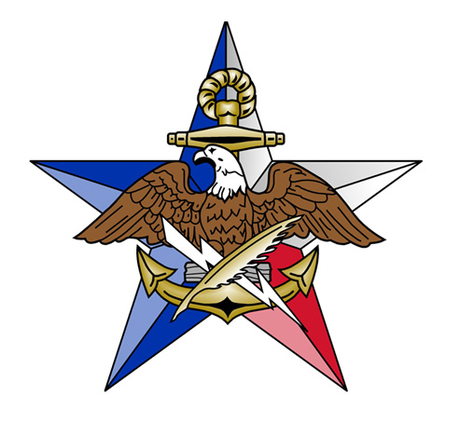
September 20-22, 2019
NAME ______________________________________________________________
GUEST NAME ______________________________________________________________
ADDRESS ______________________________________________________________
______________________________________________________________
Hotel: La Quinta Inn & Suites Marble Falls
501 Highway 2147 West
Marble Falls, TX, 78654
(830) 798-2020
Room price $129.00 PN
https://www.roomreservation.com/hotel/la-quinta-inn-suites-marble-falls.htm?msclkid=56a16c86975d1ddacdb63030b1f7a6f9

Conference Fee $25.00 PP __________
Saturday Dinner $32.00 PP __________
Ball Caps (new style) $25.00 __________
T-Shirts (new style) $20.00 __________
Circle Size(s) S M L XL XXL 2XL
Lone Star Coin (new style) $10.00 PC __________
Postage for Coin if not attending reunion $1.00 per coin __________
TOTAL __________
Make Check payable to: NCVA, Lone Star Chapter
MAIL CHECK/REGISTRATION TO Jim Gibbons
FOR MORE INFORMATION, contact:
Jim Gibbons Bob Metzger
2034 Oak Crown 306 Sheldon Lake Drive
San Antonio, TX 78232 Georgetown, TX 78633
carol1sue@yahoo.com benjubob47@gmail.com
What’s happening (POD):
Hospitality room will be open at 16:00 on Friday, Feb. 20th.
There are various event/activities to do in the Marble Falls area, here are a few suggestions/ideas:
- Saturday people can go to Market Day on Main Street which is on 10:00-16:00. There you can shop artisan goods from around the Hill Country, which include hand crafted leather goods, art carvings, and other items of interest. Approximately 70 craftsmen will be there.
- There are a couple of wineries that are open on Saturdays. Fiesta Winery has a place on Main Street where you can sample 6 wines for $15.00.
- There is a micro-brewery right behind the visitor center by the Blue Bonnet Cafe. Believe the name is Save The World Microbrewery. Friday’s hours are 15:00-19:00. Saturday’s hours are 13:00-18:00. Free tours are Friday and Saturday at 16:00.
Saturday evening’s dinner will be a ‘Soft-Taco Buffet’, consisting of:
Corn and Flour tortillas.
Beef, Chicken, Pulled-Pork, or Fried Catfish.
Toppings of Lettuce, Tomato, Onions, Sour Cream, and Salsa
Sides will include Rice and Beans.
Vegans can make bean tacos with the fixings.
Tea to drink.
Dessert will be a selection of scrumptious pies from the Blue Bonnet Cafe.
Price: $32.00 (includes taco bar, tea, & dessert).

