2017 LONE STAR NCVA REUNION
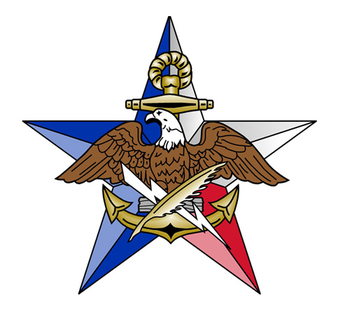
Kerrville, TX
NAME ______________________________________________________________
GUEST NAME ______________________________________________________________
ADDRESS ______________________________________________________________
______________________________________________________________
Hotel: YO Ranch Hotel and Conference Center
2033 Sidney Baker
Kerrville, TX 78028
(830) 257-4440
Room price $109.00 PN
http://www.yoranchhotel.com/

Conference Fee $25.00 PP __________
Transportation to Celtic Games $15.00PP __________
Saturday Nite Dinner $20.00 PP __________
Lone Star 2017 Kerrville T-shirt $20.00 PT __________
Size (circle) S M L XL 2X 3X (+$1.00)
NCVA Lone Star Chapter Ball Cap $22.00 PH __________
Lone Star Coin $10.00 PC __________
Postage for Coin if not attending reunion $1.00 per coin __________
TOTAL __________
Make Check payable to: NCVA, Lone Star Chapter
MAIL CHECK TO Jim Gibbons
FOR MORE INFORMATION, contact:
Jim Gibbons Bob Metzger
2034 Oak Crown 306 Sheldon Lake Drive
San Antonio, TX 78232 Georgetown, TX 78633
carol1sue@yahoo.com benjubob@gmail.com
If you have an email address, please pass it along to Jim or Bob.
Saturday Schedule:
The Kerr County Celtic Festival
Scottish Highland Games and Highland Dance Competition
http://www.kerrcountyceltic.com/home.html
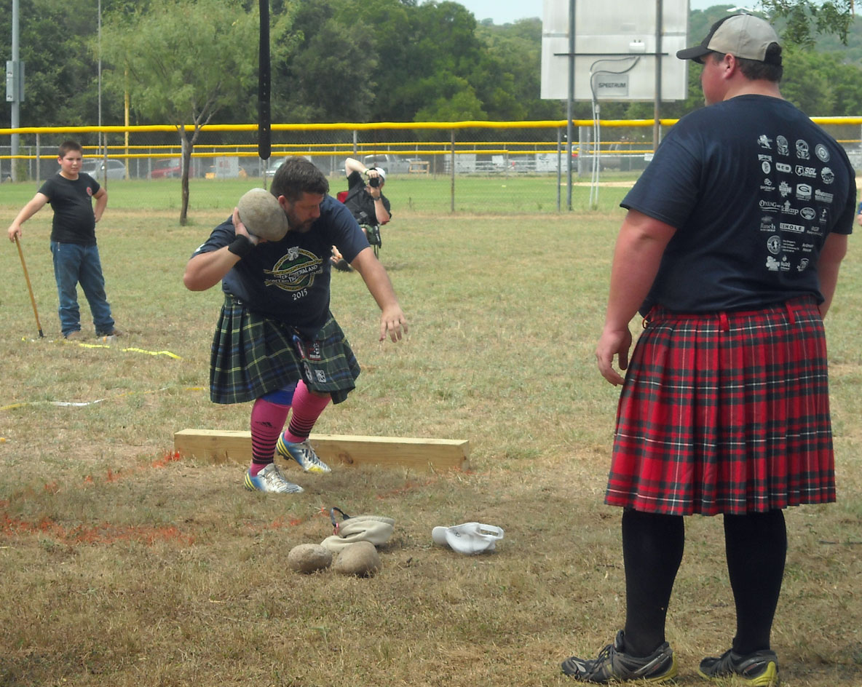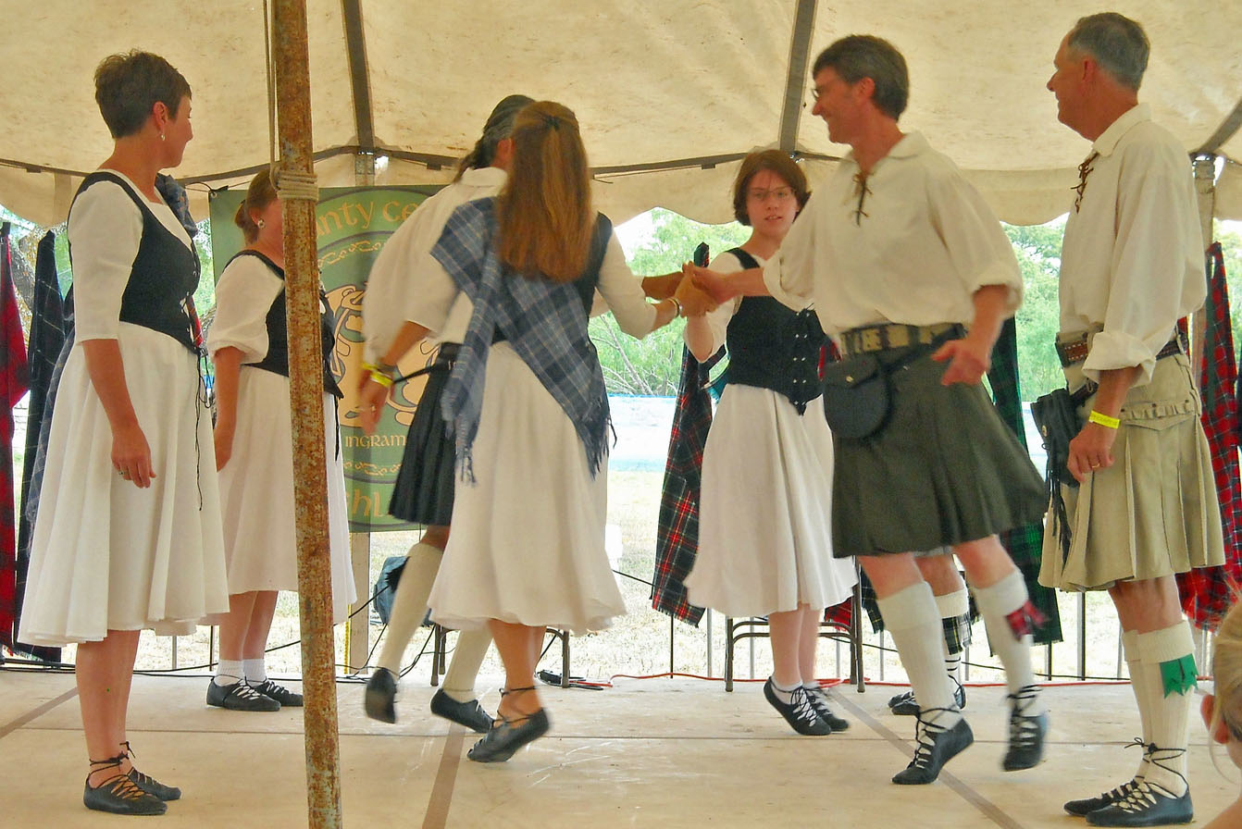
After a membership survey, the majority have chosen to attend the Scottish Games. We are checking/working on some type of transportation to/from the event site, will let you know later. Cost for entrance is ADULTS $10/DAY OR $15/WEEKEND. You can check-out the website above for further information. Actual location/directions are below.

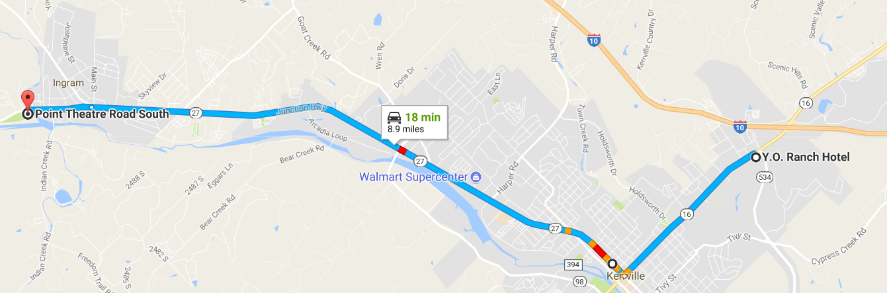
The transportation to and from the Celtic games in Ingram will cost $15 per person and will be a 15-passenger shuttle van, and will make multiple trips during the time frame we designate. Carol and Linda have the alcohol, water and soda's covered. According to Linda, for those who don't want to attend the games, there's a lot of 'neat' shops for the wives in Ingram as well.

For those individuals who would prefer to do something else, the following activities will also be happening in and around Kerrville:
10:00 AM - 4:00 PM:
Guadalupe Watercolor Group art display at Kerr Arts & Cultural Building Kerrville Outdoor Painters Event & Wet Paint Show & Sale (same place as above)
09:00 AM - 2:00 PM:
Native Plant Sale & Festival at Riverside Nature Center
09:00 AM - 6:00 PM:
Celtic Festival & Highland Games at Stonehenge II in Ingram Western Art Museum: If anyone wishes to visit, free passes can be made available but we need to know how many in advance of the Saturday reunion.

Lone Star Chapter Business/Scuttlebutt Meeting

Reunion Dinner:
Traditional Hill Country Buffet with mashed potatoes, salad, mixed veggies, roasted turkey, pork roast, roast beef and dessert is apple cobbler with whipped cream. The cost will be $20 per person. The true cost for this buffet is actually $22.95 per person; however, we've got more money in the bank than we normally keep, so I decided the organization will make up the difference.

